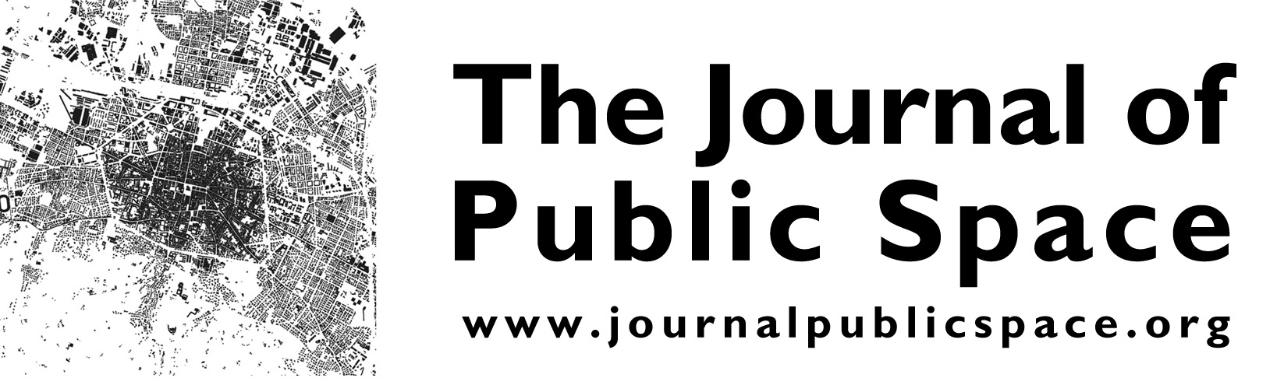
www.journalpublicspace.org
The Journal of Public Space (ISSN 2206-9658) is a research project
developed by City Space Architecture, a non-profit organization based in Italy, in partnership with UN-Habitat, the United Nations Human Settlements Programme, based in Kenya
Subscription to the Newsletter at this link: http://eepurl.com/dwGohD

CALL FOR ABSTRACTS
Universally Accessible Public Spaces for All
(tentative title)

  - S P E C I A L I S S U E
to be launched at 11th World Urban Forum (26-30 June 2022)
https://wuf.unhabitat.org/

1. Purpose
This issue, produced in partnership with the World Blind Union in line with the commitments in the Abu Dhabi Declared Actions, seeks to raise awareness and foster learning around universal design, accessibility, and inclusion in public spaces. The issue will collect research articles (academic / max 8.000 words), case studies and viewpoints (non-academic /max 3.000 words), from academia, city professionals, city managers and officials, urban planners and civil society, including organisations of persons with disabilities (OPD).
The primary weight is intended to be on the diversity of persons with disabilities, their participation in designing public spaces, and accessibility in line with the Convention on the Rights of Persons with Disabilities (CRPD) including CRPD Article 9, CRPD General Comment 2, Sustainable Development Goal 11, and the New Urban Agenda. Participation, accessibility, and universal design in line with these instruments are often overlooked in discussions and implementation of local projects related to urban spaces impacting enjoyment of rights and equality of opportunities in today’s urban areas. This issue also invites contributions reflecting perspectives on other marginalised groups in urban communities, including older persons, who face and experience accessibility barriers in public spaces.
The World Blind Union (WBU), a founding member of the International Disability Alliance, is the globally leading voice speaking on behalf of an estimated 253 million blind and partially sighted persons worldwide. Its members consist of organisations of and for blind and partially sighted persons in over 190 countries and has over 250 member organisations. WBU’s Global Program for Inclusive and Accessible Urban Development (IAUD) aims to strengthen the engagement of its members and OPD partners in the implementation of the New Urban Agenda and advocate for inclusion and accessibility in line with the CRPD and the 2030 Agenda.

2. Abstract submission and guidelines
We look for papers and contributions which evidence learnings and demonstrate levels of progress towards achieving public spaces that are accessible to and inclusive of all in line with development frameworks and human rights instruments. The issue is willing to inspire more research on the theory and practice of inclusion, deconstructing preconceived ideas/stereotypes and promoting an intersectional approach, overcoming misunderstandings and lack of efficacy in the application of the concept of universal accessibility in the drafting of policies and in the design of urban spaces.
Key issues or areas for discussion may include but are not limited to:
- Effective and appropriate measures to identify and eliminate obstacles and barriers to accessibility and ensuring equality and non-discrimination in public spaces including parks, streets, sidewalks, and footpaths that connect, playgrounds of recreation, marketplaces, etc.
- Critical role of inclusive and accessible public spaces in enabling enjoyment of human rights, improving quality of life and access to services, ensuring independent living and mobility including during emergencies and building back better after disasters, conflicts, or pandemics.
- Co-creation process, strategies and mechanisms to ensure meaningful participation and engagement of diverse marginalized groups, including all persons with disabilities in line with CRPD General Comment 7.
- Effective implementation and monitoring of adequate accessibility standards across various forms of public spaces and across main areas of accessibility including the physical environment, information and communications (including systems and technologies), transport.
- Strategies to address accessibility, reasonable accommodation, and universal design together with key considerations such as intersectionality, gender equality, resilience, health, economic, engineering, cultural, environmental, maintenance and safety issues, etc.
- Learnings and experiences on how to promote a universal design approach and mainstream accessibility into local policies, plans, budgets, programs, and practices related to public spaces.
- Capacities, data and tools needed to assess and address accessibility gaps/pitfalls, measure impact and guide the design and realisation of inclusive and accessible public spaces at local levels.

Please kindly submit your abstract proposal to: submission@journalpublicspace.org
Only authors who will receive a notification of acceptance of abstracts will be entitled to submit full papers.

2.1 Author’s Guidelines for Abstracts
- Research articles (academic): title, names of all authors with the email address of the corresponding author, extended abstract of max 600 words with up to five keywords. Images can be included as well, up to three, with captions and alternative text.
- Case studies and viewpoints (non-academic): title, names of all authors with the email address of the corresponding author, extended abstract of max 600 words with up to five keywords. Images can be included as well, up to three, with captions and alternative text.

2.2 Author’s Guidelines for Full Papers
- Research articles (academic): full papers between 5.000 and 8.000 words, the word limit includes notes and bibliographical references. The submission must include also an abstract of max 300 words, up to five keywords, and up to 20 copyright free images with captions and alternative text.
- Case studies and viewpoints (non-academic): full papers of max 3.000 words, the word limit includes notes and bibliographical references. The submission must include also an abstract of max 300 words, up to five keywords, and up to 20 copyright free images with captions and alternative text.

Read also: Submission Checklist available on The Journal of Public Space’s website.

For comprehensive guidance on accessibility, please read and use Accessibility Go! A Guide to Action a practical resource that provides support on how to deliver accessibility across systems, programs and practices including tools, references, and a glossary of key terms.

3. Important dates and deadlines
- Submission of abstracts: 15 October 2021 > extended to 7 November 2021
- Notification of acceptance: 1 November 2021 > extended to 15 November 2021
- Submission of full papers: 15 December 2021 > extended to 21 December 2021
- Comments from peer reviewers sent to authors: 30 January 2022
- Submission of the final paper ready for publication: 15 March 2022
- Publication (expected): May 2022

4. Contact information
For any additional questions, please write to:
Dr Luisa Bravo, Founder and Editor in Chief, The Journal of Public Space, luisa.bravo@journalpublicspace.org
Mr Hannes Lagrelius, World Blind Union, Program Officer, Bilateral Associate Expert, Global Program for Inclusive & Accessible Urban Development
Hannes.Lagrelius@wbu.ngo

* This call for abstracts will be published together with a CALL FOR REVIEWERS (specific expertise) and a CALL FOR ASSITANT EDITOR(S) (specific expertise).

CALL FOR REVIEWERS
The Journal of Public Space is looking for peer reviewers to contribute to the development of this special issue. These are the desirable profiles:
- for research articles, senior academic scholars with proven expertise on universal design, accessibility, and inclusion in public spaces
- for case studies and viewpoints, scholars and/or professionals (city-managers, architects, urban planners and designers, community leaders, civil society representatives including Organisations of Persons with Disabilities, NGO representatives, etc.) that have already developed projects or initiatives focused on universal design, accessibility, and inclusion in public spaces, with at least 5 years of experience.

We expect to receive expressions of interest to serve as peer reviewers, considering that availability must be aligned with the dates and datelines indicated for the review process and final production.

Peer reviewers are supposed to provide comments on submitted full papers, in regard of structure, legibility and originality, with feedbacks to existing literature and/or key research studies, initiatives and policies, to help authors to improve the quality of their work.
Peer reviewers will not be compensated but will receive a letter of appreciation from the Editor in Chief as soon as the issue is published.

Please kindly submit your expression of interest, including a short bio, to: reviewer@journalpublicspace.org no later than 1 October 2021 > extended to 1 November 2021

CALL FOR ASSISTANT EDITOR
The Journal of Public Space is looking for 1 or 2 assistant editors for this special issue. The desirable candidate is a PhD student or a postgraduate professional with at least two years of experience in research and practice on inclusion and universal accessibility.
We expect to receive expressions of interest to serve as assistant editor, considering that availability must be aligned with the dates and datelines indicated for the review process and final production.
Assistant editors will work with the Editor in Chief and with the Editorial team in all stages of the publication process, interacting with authors and peer reviewers, checking articles and supporting the final design layout.
Assistant editors will not be compensated but will receive a letter of appreciation from the Editor in Chief as soon as the issue is published.
Please kindly submit your expression of interest, including a short bio, to: editor@journalpublicspace.org no later than 1 October 2021 > extended to 1 November 2021

Read about The Journal of Public Space’s mission and policies: https://www.journalpublicspace.org/index.php/jps/about

